FULL STACK DEVELOPMENT WITH MERN
Cab Booking
Project Documentation

Team Lead: Paidipati Manikumar
Date: 15 July 2026
github.com/manikumar26092005/Cab-Booking-Premium

1. Introduction
Project Title: Cab Booking
Team Members:
Name | Email | Role
Paidipati Manikumar | pmanikumar2005@gmail.com | Team Lead
Godugunuru Penchala Raviteja | godugunuruteja@gmail.com | Member
Puli Mokshagna | mokshapuli7@gmail.com | Member
Panthagani Rupan Raj | panthaganirupanraj@gmail.com | Member
Sai Ganesh Uday Kiran Bokkasam | udaykiranroyals9099@gmail.com | Member

2. Project Overview
Purpose: Cab Booking is a full-stack cab booking web application that connects urban commuters (Riders) with cab Drivers through a transparent, real-time booking system, while giving platform Admins centralized control over users, drivers, cars, bookings, and analytics.
Key Features:
- Role-based portals for Rider, Driver, and Admin with dedicated dashboards
- JWT-based authentication and role-based access control (RBAC)
- Ride booking with pickup/drop location, date, time, and fare estimation by distance
- Five-stage booking lifecycle: Pending → Driver Assigned → Accepted → On the Way → Completed (with Cancelled as an exit state)
- Automated driver assignment and driver accept/manage workflow
- Driver earnings tracking (today's earnings, total earnings, completed rides)
- Rider ride history ('My Rides') with downloadable PDF receipts
- Admin platform overview: total users, cars, drivers, and bookings at a glance
- Admin management of Users, Drivers, Cars, and Bookings, with search and status filters
- Admin Reports section with analytics dashboards

3. Architecture
Frontend: Built with React (Vite) as a single-page application. Three distinct UI contexts — Rider, Driver, and Admin — share a common design language (dark theme, amber/orange accent) and consume the backend REST API via authenticated HTTP requests.
Backend: Built with Node.js and Express.js following the MVC (Model-View-Controller) pattern. Controllers handle Booking, User, Driver, Car, and Payment logic; routes are grouped by resource and protected by JWT/RBAC middleware; 35 REST endpoints are exposed in total.
Database: MongoDB (Community Server, local instance) with five core collections — Users, Drivers, Cars, Bookings, and Reviews/Payments — linked by referenced ObjectIds (e.g., a Booking references a User, a Driver, and a Car).

4. Setup Instructions
Prerequisites:
- Node.js (v18 or later) and npm
- MongoDB (Community Server, running locally on the default port)
- Git
Installation:
- Clone the repository: git clone https://github.com/manikumar26092005/Cab-Booking-Premium.git
- Install server dependencies: cd server && npm install
- Install client dependencies: cd client && npm install
- Create a .env file in the server directory with MONGO_URI, JWT_SECRET, and PORT variables
- Start MongoDB locally before running the server

5. Folder Structure
Client (React frontend): organized by feature — components/ (shared UI elements), pages/ (Rider, Driver, and Admin pages), context/ (auth context for JWT session state), services/ (API call wrappers), and App.jsx as the routing entry point.
Server (Node.js backend): organized by MVC layer — models/ (Mongoose schemas for User, Driver, Car, Booking), controllers/ (business logic per resource), routes/ (Express route definitions), middleware/ (JWT auth and role-based access control), and server.js as the entry point.

6. Running the Application
Frontend: from the client directory, run npm run dev (Vite dev server, default http://localhost:5173).
Backend: from the server directory, run npm start (Express server, default http://localhost:5000).

7. API Documentation
A summary of key REST endpoints (35 total across all resources):
Method | Endpoint | Description
POST | /api/auth/register | Register a new Rider, Driver, or Admin account
POST | /api/auth/login | Authenticate a user and issue a JWT token
GET | /api/users | Admin: list all registered users
GET | /api/drivers | Admin: list all drivers with status and earnings
POST | /api/cars | Admin: add a new car to the fleet
POST | /api/bookings | Rider: create a new ride booking
GET | /api/bookings/my-rides | Rider: view personal ride history
PATCH | /api/bookings/:id/status | Driver: update the status of an assigned ride
PATCH | /api/bookings/:id/assign | Admin: assign a driver to a booking
GET | /api/bookings/:id/receipt | Rider: generate/download a PDF receipt for a completed ride
GET | /api/reports/summary | Admin: fetch platform analytics summary

8. Authentication
Cab Booking uses JSON Web Tokens (JWT) for stateless authentication. On successful login, the server issues a signed JWT containing the user's ID and role (Rider, Driver, or Admin), which the client stores and attaches as a Bearer token on subsequent API requests. Backend middleware verifies the token's validity and checks the embedded role against each route's required permissions before allowing access, so, for example, only Admin-role tokens can reach driver/car/user management endpoints.

9. User Interface
Login screen — shared entry point for Rider, Driver, and Admin roles:
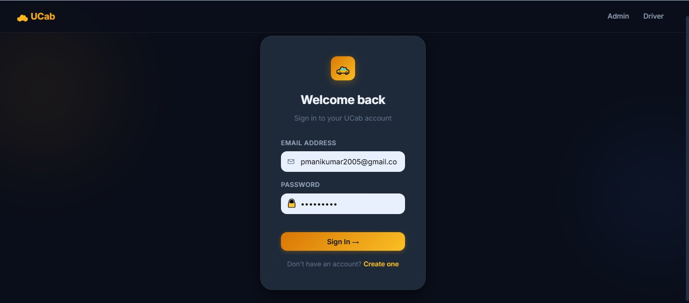
Figure 1: UCab sign-in screen
Rider — Book a Ride screen with fare estimation:
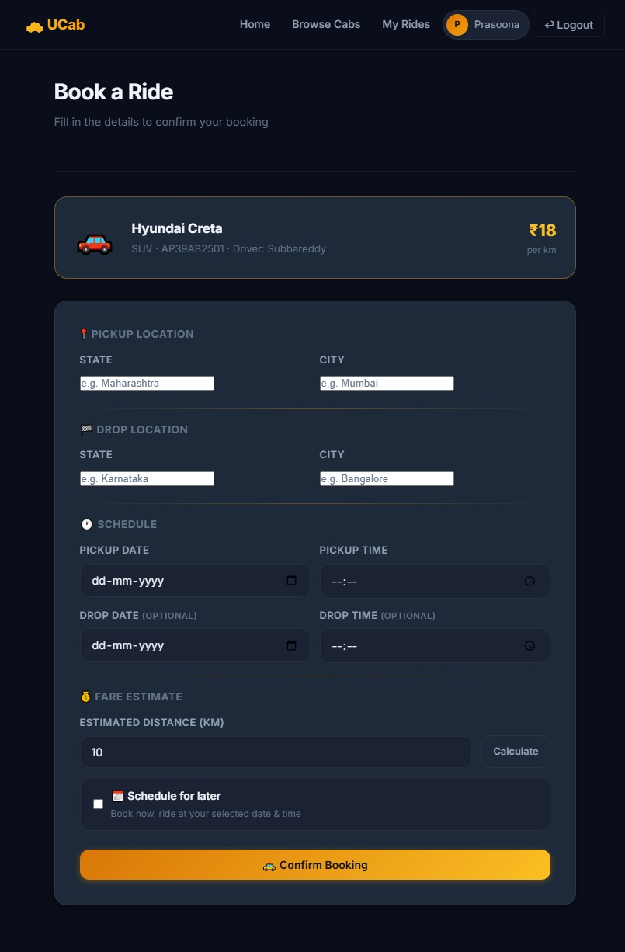
Figure 2: Rider booking flow with pickup/drop details and fare estimate
Driver Dashboard — earnings and assigned rides:
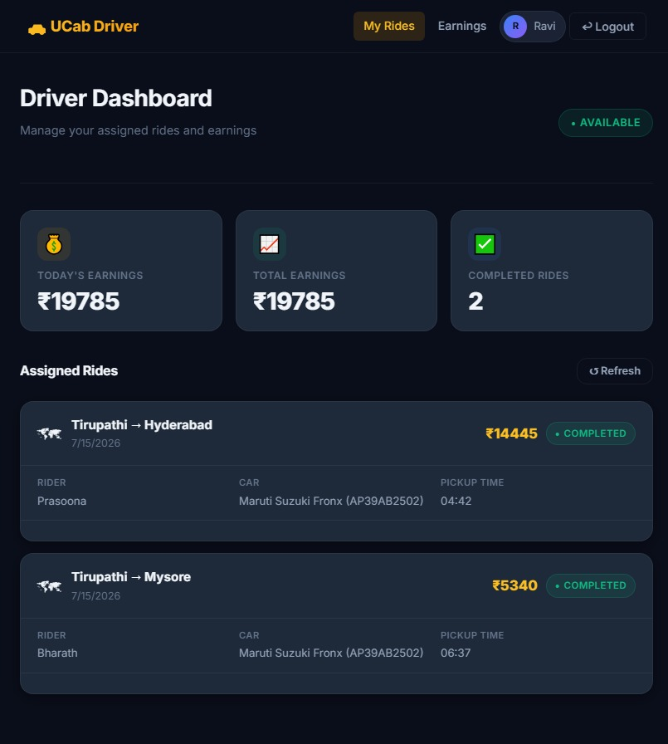
Figure 3: Driver dashboard showing today's/total earnings and completed rides

10. Testing
The application was validated through Functional & Performance Testing (input validation, booking flow, JWT/RBAC enforcement, API response time, concurrent booking load, and PDF/dashboard load testing) and a full User Acceptance Testing (UAT) cycle covering Registration & Login, Booking Management, Driver Assignment, Payment & Receipt Generation, Ratings & Reviews, Admin Analytics, and Security modules — 59 test cases in total, all passing, with 27 logged defects triaged and closed prior to release. Full details are documented in the separate Functional & Performance Testing Template and UAT deliverables.

11. Screenshots / Demo
Admin — Platform Overview dashboard:
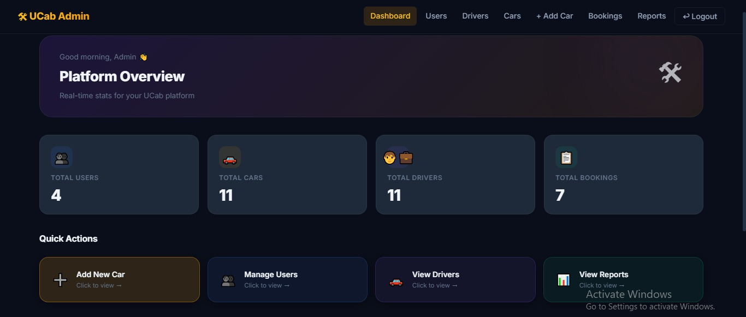
Figure 4: Admin dashboard showing total users, cars, drivers, and bookings
Admin — Bookings management with live status:
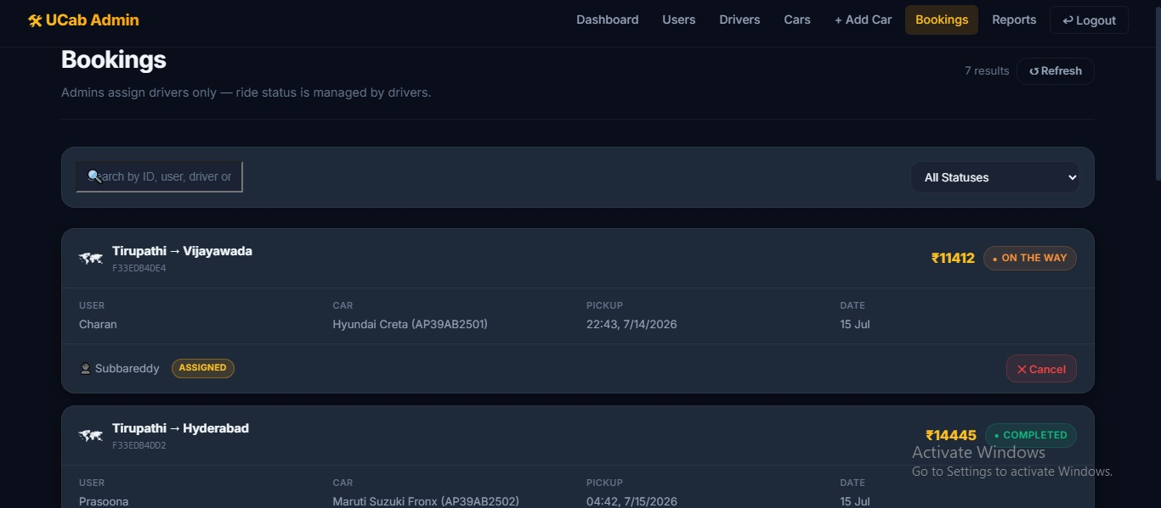
Figure 5: Admin bookings list with status filter and per-ride details
Admin — Drivers management with earnings and vehicle assignment:
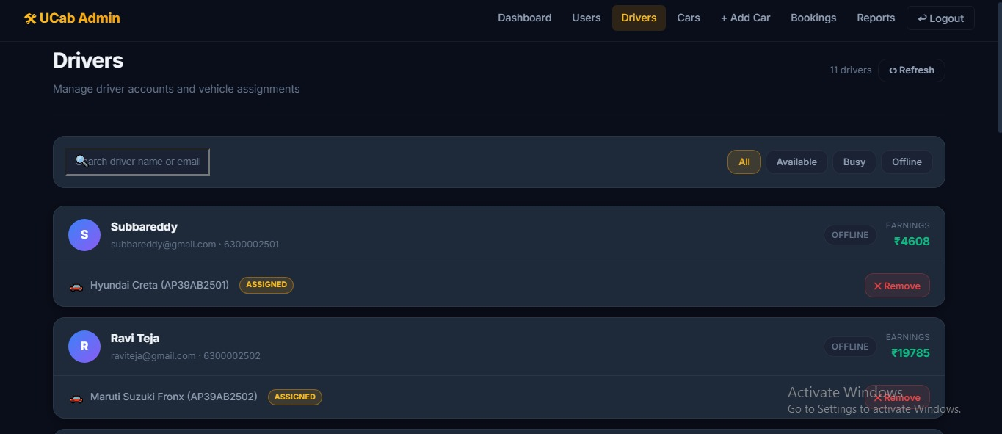
Figure 6: Admin drivers list with availability status and earnings
Rider — My Rides history with receipt download:
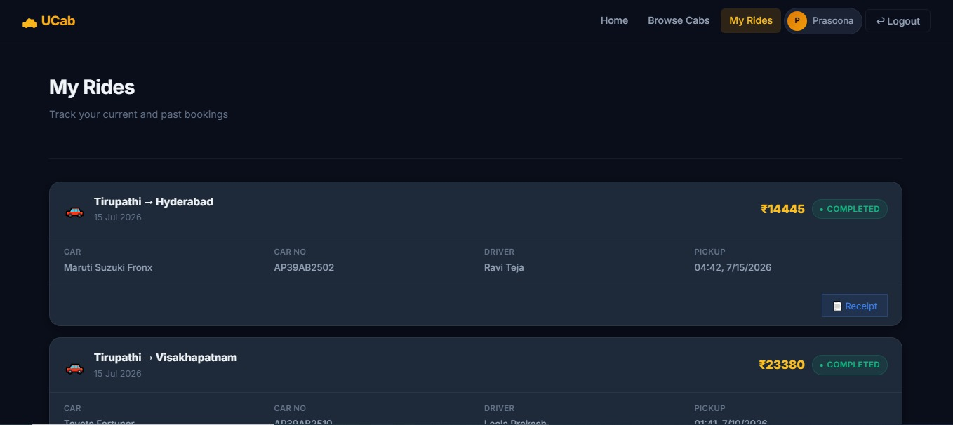
Figure 7: Rider ride history with completed trips and receipt access
Driver — Assigned rides detail view:
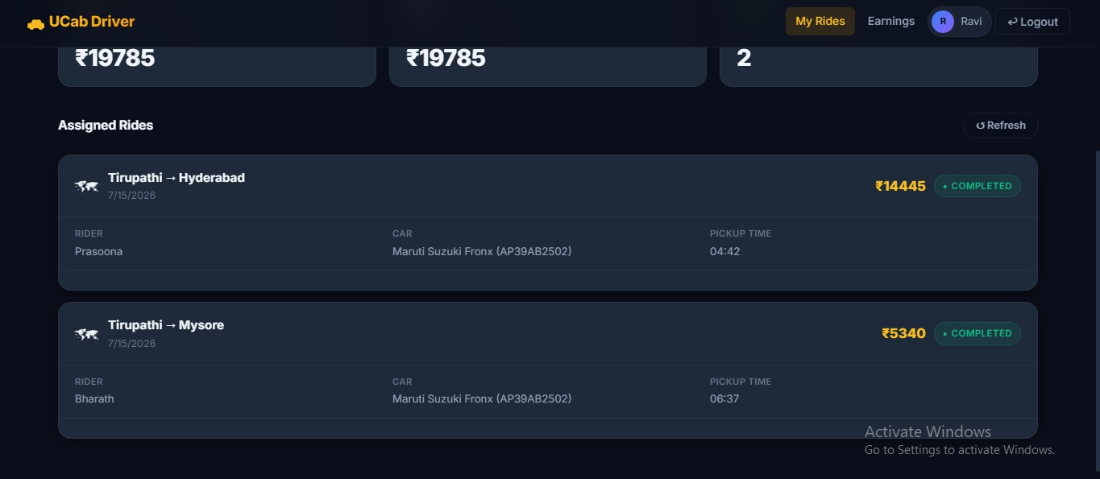
Figure 8: Driver's assigned rides with rider, car, and pickup-time details
GitHub Repository: https://github.com/manikumar26092005/Cab-Booking-Premium
Demo Video/Folder: https://drive.google.com/drive/folders/1ZDpZ5FvcYIxTEkNpBHU6LG2rhIIjf5tR

12. Known Issues
- Fare estimate could briefly show a stale value when the drop location was changed quickly (resolved by re-triggering fare calculation on location change).
- Concurrent bookings in the same area could occasionally attempt duplicate driver assignment (resolved by adding assignment locking at the database level).
- The application currently runs against a local MongoDB instance; multi-region or high-availability deployment has not yet been configured.

13. Future Enhancements
- Live map-based driver tracking during the 'On the Way' status
- In-app chat or call bridge between rider and driver
- Online payment gateway integration (currently fare is calculated and receipted, without a live payment gateway)
- Scheduled/advance ride booking refinements and reminders
- Migration from local MongoDB to MongoDB Atlas and cloud hosting for production scalability
- Push notifications for booking status changes

